***Correlational Research between XY and ODD-EVEN Routing Algorithm on NoX simulator Network – on - Chip***

Cheruku Venkata Sai Bharagva Reddy and Kakke Dhaman Kumar

*Abstract*— The design challenges of System-on-Chip are solved by Network-on-Chip which act as a paradigm. In NoC design one of the key researches is the Routing Algorithm. The distributed deterministic routing algorithm which is XY routing algorithm is simple to be implement, whereas Odd-Even (OE) routing algorithm is complex and a sort of distributed adaptive routing algorithm with deadlock-free ability. We demonstrate the two routing algorithms that is OE and XY routing algorithms at first which are then simulated and compared based on Mesh topology NoC with NoC simulator.

Keywords—Network-on-Chip; System-on-chip; XY routing Algorithm; Odd-Even Routing Algorithm.

1. INTRODUCTION

The System-on-chip (SoC) design provides an integrated solution to challenging design problems in the telecommunication , multimedia, consumer electronics domain. The designs of SoCs encounter some challenges with the advanced process technologies and SoC complexity scales.

The negative effect of challenges is faced due to technology scaling on global interconnects, growing system complexity. The need to construct flexible multi-use designs and platforms and so on. The routing algorithm is one of key researches of a NoC design, the Network-on-Chip (NoC) has been recognized to solve these challenges.

In this paper, we give an overview of NoC design approach in section two at first and then in section three, we present details of XY and Odd-Even (OE) routing algorithm. In Section four gives the architecture of a 3X3 mesh topology NoC. In section five Simulation results and analysis based on this topology. At last, conclusions are provided.

**2. NoC DESIGN APPROACH OVERVIEW**

In NoC design approach, designers use network design technology to analyze and design SoC’s. Designers view SoC as a micro-network of components. Interconnection design of the SoC can be done using the micro-network stack paradigm, that is an adaption of the functional properties of the interconnection can thus be abtracted.

The physical implementation of the communication channels is the Global Wires. The shift towards faster and lower-power communication may decrease reliability as a aide effect. In NoC design approach the physical layer design finds a compromise between competing quality metrics and thus provide a clean and complete abstraction of channel characteristics to above micro-network layers. The main purpose of a data link up to minimum number required. Under the assumption of the physical layer by itself is not sufficiently reliable.

At the network layer, the transmission of the packet data transmission can be customized by the choice of switching and that of the routing algorithms. The former, that is the circuit, packet, and cut-through switching, establishes the type of connection while the latter determine the path followed by a message through the network to its final destination. The performance is heavily affected by the Switching and routing algorithms. The communication network layer is atop end-to0end connection abstraction. In the transport layer the message is decomposed into packets at the source.

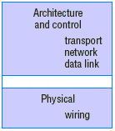

Fig: The protocol stack from which the stack paradigm of network on a chip can be adapted.

**3 XY AND OE ROUTING ALGORITHM**

The routing algorithm which defines the path taken by a packet. Between the source and the destination, the main task in the network layer design of NoC. Where routing decisions are taken it is possible to classify the routing in source and destination routing. In source routing the whole path is decided at the source router. In the distributed routing each router receives a packet and decides the direction to send it. According to how a path is defined to transmit packets, it can be classified as adaptive or deterministic. In deterministic routing, the path is uniquely defined by the source and target addresses whereas in adaptive routing, the path is a function of the network traffic. In the following text, two different routing algorithms XY and ODD-EVEN are demonstrated in detail.

1. **XY ROUTING ALGORITHM**

The XY routing algorithm is one type of distributed deterministic routing algorithms. For a 2-Dimesion mesh topology NoC, each router can be identified by its coordinate (x, y) (Fig. 2).

The XY routing algorithm compares the current router address (Cx, Cy) to the destination router address (Dx, Dy) of the packet, stored in the header flit. Flits must be routed to the core port of the router when the (Cx, Cy) address of the current router is equal to the (Dx, Dy) address.

If this is not the case, the Dx address is firstly compared to the Cx (horizontal) address. Flits will be routed to the East port when Cx<Dx, to West when Cx>Dx and if Cx=Dx the header flit is already horizontally aligned. If this last condition is true, the Dy (vertical) address is compared to the Cy address. Flits will be routed to South when Cy<Dy, to North when Cy>Dy.

If the chosen port is busy, the header flit as well as all subsequent flits of this packet will be blocked. The routing request for this packet will remain active until a connection is established in some future execution of the procedure in this router. The following text is the algorithm XY:

**Algorithm XY:**

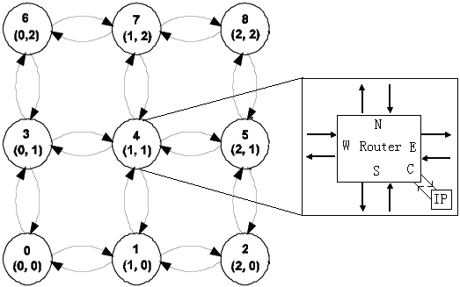

FIG: A 2-D 3X3 Mesh Topology Network on Chip

1. **ODD-EVEN ROUTING ALGORITHM**

OE routing algorithm is a distributed adaptive routing algorithm which is based on odd-even turn model. It exerts some restrictions, for avoiding and preventing from deadlock appearance. Odd-even turn model facilitates deadlock-free routing in two-dimensional (2D) meshes with no virtual channels. Explaining some definitions are necessary in order to represent this algorithm.

In a two-dimension mesh with dimensions X*Y each node is identified by its coordinate (x, y). In this model, a column is called even if its x dimension element is even numerical column. Also, a column is called odd if its x dimension element is an odd number. A turn involves a 90- degree change of traveling direction. A turn is a 90-degree turn in the following description. There are eight types of turns, according to the traveling directions of the associated channels. A turn is called an ES turn if it involves a change of direction from East to South. Similarly, we can define the other seven types of turns, namely EN, WS, WN, SE, SW, NE, and NW turns, where E, W, S, and N indicate East, West, South, and North, respectively. As a whole, there are two main theorems in odd-even algorithm:

Theorem1: NO packet is permitted to do EN turn in each node which is located on an even column. Also, No packet is permitted to do NW turn in each node that is located on an odd column.

Theorem 2: NO packet is permitted to do ES turn in each node that is in an even column. Also, no packet is permitted to do SW turn in each node which is in an odd column.

The following test is a minimal OE routing algorithm in which avail_dimension_set contains dimensions that are available for forwarding the packet:

**Algorithm ODD-EVEN:**

OE routing algorithm is more complex than XY routing algorithm. However, it is one kind of adaptive routing algorithm. For a pair of source and destination, it can provide a group of routing paths and it can prevent from dead lock appearance.

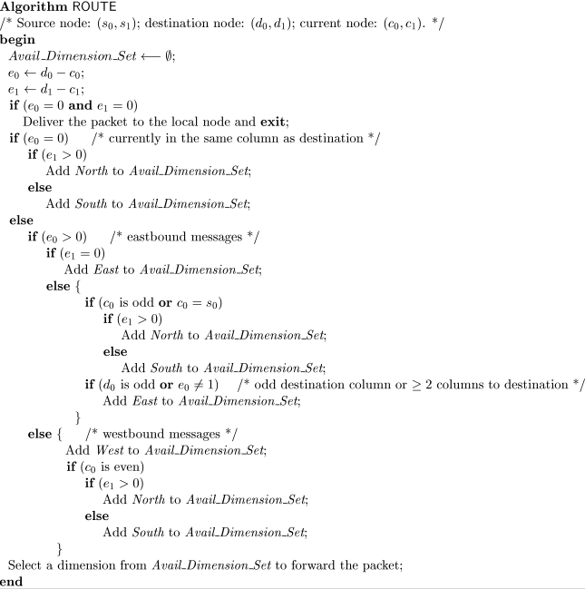

Fig 1 Odd-Even Algorithm

**4 ARCHITECTURE OF A 2-DIMENTIONAL MESH TOPOLOGY NOC**

The routing Algorithm is simulated based on a 2- Dimension 3X3 mesh topology NoC (Fig. 2). In the Fig. 2, each circle represents a tile in the network. Each tile consists of an IP core connected to a router by a bidirectional core channel (C). A tile is connected to neighbor tiles by four bidirectional channels (N, E, S and W). Each tile is identified by a unique integer ID. Also, each tile can be identified by a pair x-coordinate and y-coordinate. Our 2-Dimesion 3X3 mesh topology NoC is designed using wormhole switching mechanism, in which packets are divided into flits. A packet consists of 3 types of flits, which are head flit, data flit and tail flit. We have implemented the architecture consisting of only input buffers. The number of buffers is 8 in input channel FIFO. Both XY routing algorithm and OE routing algorithm are based on these characteristics.

**5 SIMULATION RESULTS AND ANALYSIS**

In this section we have evaluated the implemented algorithms against different traffic patterns and compared against different algorithms. We have used NOX simulator to run the simulations. Performance and power plots are done for each algorithm against 4 different traffic patterns. As we have developed the algorithms only for mesh topology the 8*8 mesh topology has been used for the evaluation. Number of VC used is 8 with a buffer depth of 4.

Message length was set to 4 with maximum messages to 1000000.

Arbitration used is Round robin with a load rate of 0.02.

Below are the simulation results we have got for each traffic pattern.

|  |  |  |  |
| --- | --- | --- | --- |
| Deterministic algorithm | | | |
| Traffic Pattern | Avg. Message Latency | Traffic Pattern | Avg. Energy per Message |
| NR | 26.562690 cycles | NR | 0.195968 nJ(10^-9) |
| TP | 25.015116 cycles | TP | 0.195777 nJ(10^-9) |
| BC | 33.753302 cycles | BC | 0.277032 nJ(10^-9) |
| NB | 10.431236 cycles | NB | 0.070256 nJ(10^-9) |

Table 1. Deterministic Algorithm/XY Algorithm

|  |  |  |  |
| --- | --- | --- | --- |
| Odd-Even Algorithm | | | |
| Traffic Pattern | Avg. Message Latency | Traffic Pattern | Avg. Energy per Message |
| NR | 25.015236 cycles | NR | 0.195779 nJ(10^-9) |
| TP | 26.616686 cycles | TP | 0.196185 nJ(10^-9) |
| BC | 35.525996 cycles | BC | 0.277461 nJ(10^-9) |
| NB | 10.439767 cycles | NB | 0.070327 nJ(10^-9) |

Table 3. Odd-Even Algorithm

Below are the plotted graphs

Fig: Performance analysis plot for routing algorithm vs avg message latency for XY and ODD-EVEN

Fig: Power analysis plot for routing algorithm vs avg energy per message for XY and ODD-EVEN

**6 Conclusion**

From above simulation report we can see that only for the NR traffic pattern ODD-EVEN performance better than XY algorithm but initially we expected that ODD EVEN would perform better than XY algorithm in all cases, as there was no availability of source node at the function parameters in NoX simulator we discarded one of the paths which was the major reason for the impact on performance of the algorithms. From the simulation we can see that in all the other traffic patterns XY and ODD-EVEN algorithms had performed almost the same way. When we calculate the overall development and simulation efforts, XY algorithm was easy to develop and use whereas ODD EVEN was difficult to develop and implement, this is the major reason for XY algorithm to be more widely use.

1. **References**

[1] https://libproxy.library.unt.edu:2301/document/5209133

[2] P. Guerrier and A. Greiner, “A generic architecture for on-chip packet-switched interconnections,”Proc. Design, Automation and Test in Europe Conference and Exhibition (DATE 2000), Mar. 2000, pp. 250–256, doi: 10.1109/DATE.2000.840047.

[3] A. Hemani, A. Jantsch, S. Kumar, A. Postula, J. Oberg, M. Millberg. et al, “Network on a chip: an architecture for billion transistor era,” Proc. IEEE NorChip, 2000.

[4] W. Dally and B. Towles, “Route packets, not wires on-chip interconnection networks,” Proc. Design

Automation Conference, Jun. 2001, pp. 684–689.

[5] M. Sqroi, M. Sheets, A. Mihal, K. Keutzer, S. Malik, J. Rabaey, et al.“Addressing the system-on-a-chip interconnect woes through communication-based design”, Proc. Design Automation Conference, Jun 2001, pp.667-672.

[6] S. Kumar, A. Jantsch, J. Soininen, M. Forsell, M. Millberg, J. Oberg . et al, “A network on chip architecture and design methodology,” Proc. IEEE Computer Society Annual Symposium on VLSI, Apr. 2002, pp. 105-112,doi:10.1109/ISVLSI.2002.1016885.

[7] R. Marculescu, H. Jingcao, U. Y. Ogras, “Key research problems in NoC design: a holistic perspective,” Proc. Third IEEE/ACM/IFIP

International Conference on Hardware/Software Codesign and System Synthesis (CODES+ISSS’05) , Sept. 2005, pp.69-74, doi: 10.1145/1084834.1084856.

[8] J. Walrand, P. Varaiya, High-performance communication networks. Morgan Kaufman, 2000.

[9] J. Duato, S. Yalamanchili, L. Ni, Interconnection networks: an engineering approach, Morgan Kaufmann, Revised Edition, 2002.

[10] L. M. Ni, P. K. Mckinley, “A Survey of Wormhole Routing Techniques in Direct Networks”, Computer, vol. 26(2), Feb 1993, pp. 62 –76, doi: 10.1109/2.191995